**UTS**

Nama :Achmad Musa Firdaus

Kelas :PTI20B

Nim :20050974068

package com.mycompany.uts;

public class Employee {

private String name;

private int idNumber;

private String department;

private String position;

public Employee() {

}

public Employee(String name, int idNumber, String department, String position) {

this.name = name;

this.idNumber = idNumber;

this.department = department;

this.position = position;

}

public static void main(String[] args) {

Employee first = new Employee("Susan Meyers", 47899, "Marketing", "Sales Rep");

Employee second = new Employee("Mark Jones", 39119, "IT", "Programmer");

Employee third = new Employee("Joy Rogers", 81774, "Manufacturing", "Engineer");

System.out.println(first);

System.out.println(second);

System.out.println(third);

}

public String getName() {

return name;

}

public void setName(String name) {

this.name = name;

}

public int getIdNumber() {

return idNumber;

}

public void setIdNumber(int idNumber) {

this.idNumber = idNumber;

}

public String getDepartment() {

return department;

}

public void setDepartment(String department) {

this.department = department;

}

public String getPosition() {

return position;

}

public void setPosition(String position) {

this.position = position;

}

@Override

public String toString() {

return String.format("data: %s %s %s %s", name, idNumber, department, position);

}

}

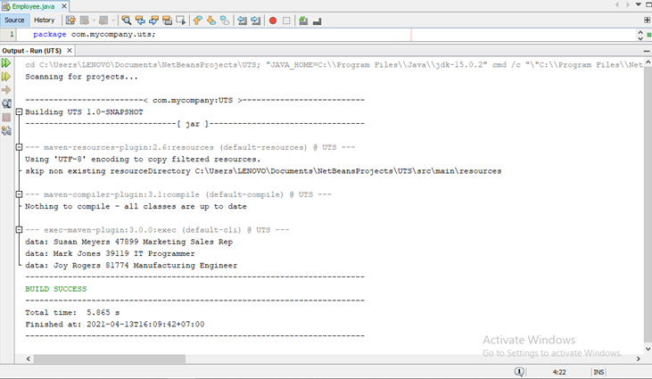

#include <iostream>

#include <iomanip>

#include <string>

using namespace std;

class RetailItem

{

private:

string description;

int unitsOnHand;

double price;

public:

RetailItem(string d, int u, double p)

{ description = d; unitsOnHand = u; price = p; }

void setDescription(string d)

{ description = d; }

void setUnitsOnHand(int u)

{ unitsOnHand = u; }

void setPrice(double p)

{ price = p; }

string getDescription()

{ return description; }

int getUnitsOnHand()

{ return unitsOnHand; }

double getPrice()

{ return price; }

};

void displayItem(RetailItem);

int main()

{

RetailItem item1("Jacket", 12, 59.95);

RetailItem item2("Designer Jeans", 40, 34.95);

RetailItem item3("Shirt", 20, 24.95);

displayItem(item1);

displayItem(item2);

displayItem(item3);

return 0;

}

void displayItem(RetailItem item)

{

cout << setprecision(2) << fixed << showpoint;

cout << "Description: " << item.getDescription() << endl;

cout << "Units on hand: " << item.getUnitsOnHand() << endl;

cout << "Price: $" << item.getPrice() << endl << endl;

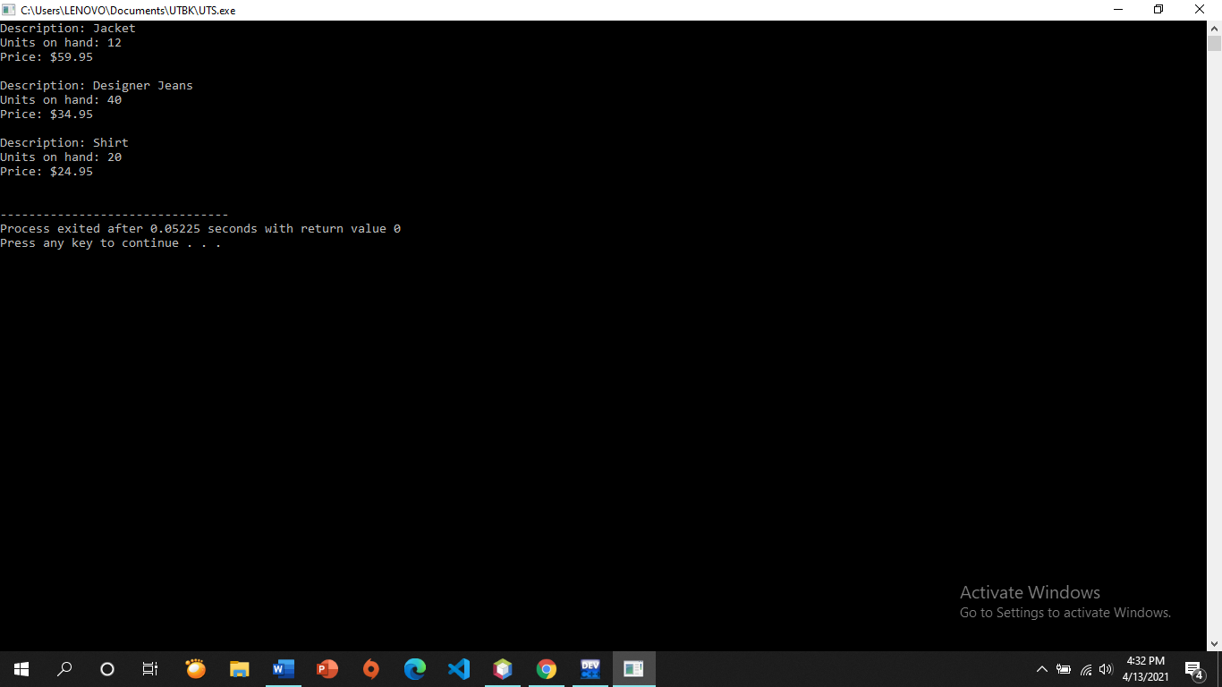

}

<?php

class Circle

{

private $radius;

private $pi = 3.14159;

public function __construct() {

$this->radius = 0.0;

$a = func_get_args();

$b = func_num_args();

if (method_exists($this, $function = '__construct'.$b)) {

call_user_func_array(array($this, $function), $a);

}

}

public function __construct1($radius) {

$this->radius = $radius;

}

public function setRadius($radius)

{

$this->radius = $radius;

}

public function getRadius(){

return $this->radius;

}

public function getArea()

{

return $this->pi*$this->radius*$this->radius;

}

public function getDiameter()

{

return $this->radius*2;

}

public function getCircumference()

{

return 2*$this->pi*$this->radius;

}

}

$ling1 = new Circle();

$ling2 = new Circle(12);

if(isset($_POST['r'])){

$ling1->setRadius($_POST['r']);

}

?>

<!DOCTYPE html>

<html>

<head>

<title>Hitung Lingkaran OOP</title>

<meta charset="utf-8">

<meta http-equiv="X-UA-Compatible" content="IE=edge">

<title></title>

<meta name="description" content="">

<meta name="viewport" content="width=device-width, initial-scale=1">

<link rel="stylesheet" href="bootstrap/css/bootstrap.min.css">

<script src="bootstrap/js/bootstrap.min.js"></script>

</head>

<body>

<div class="jumbotron jumbotron-fluid">

<div class="container">

<h1>Hitung Lingkaran</h1>

<p>menghitung lingkaran dengan prinsip OOP sederhana</p>

<form class="form-inline" action="" method="post">

<div class="row">

<div class="col">

<input type="text" class="form-control" id="radius" placeholder="masukan radius" name="r" required>

</div>

<div class="col">

<button type="submit" class="btn btn-primary">Submit</button>

</div>

</div>

</form>

</div>

</div>

<div class="container">

<ul class="list-unstyled">

<li><?php echo "Diameter = ".$ling1->getDiameter(); ?></li>

<li><?php echo "Keliling = ".$ling1->getCircumference(); ?></li>

<li><?php echo "Luas = ".$ling1->getArea(); ?></li>

</ul>

</div>

</body>

</html>

#include <iostream>

#include <string>

using namespace std;

class PersonData

{

private:

string name, address;

int phoneNumber;

public:

void setName(string name){

this->name = name;

}

string getName(){

return name;

}

void setAddress(string address){

this->address = address;

}

string getAddress(){

return address;

}

void setPhoneNumber(int phoneNumber){

this->phoneNumber = phoneNumber;

}

int getPhoneNumber(){

return phoneNumber;

}

};

class CustomerData : public PersonData

{

private:

int customerNumber;

bool mailingList;

public:

void setCustomerNumber(int customerNumber){

this->customerNumber = customerNumber;

}

int getCustomerNumber(){

return customerNumber;

}

void setMailingList(bool mailingList){

this->mailingList = mailingList;

}

int getMailingList(){

return mailingList;

}

};

int main() {

CustomerData cust;

cust.setCustomerNumber(0974068);

cust.setMailingList(true);

cust.setName("Musa");

cust.setAddress("Desa Mancilan,61482");

cust.setPhoneNumber(6886);

cout<<"Customer Number : "<< cust.getCustomerNumber()<<endl;

cout<<"\nName : "<< cust.getName()<<endl;

cout<<"\nAddress : "<<cust.getAddress()<<endl;

cout<<"\nPhone : "<<cust.getPhoneNumber()<<endl;

cout<<"\nMailing List: "<<cust.getMailingList()<<endl;

return 0;

}

name

addres

start input data

mailing list

phone

* **Person and Customer Classes**

#include <iostream>

#include <string>

#include "PersonData.h"

using namespace std;

PersonData::PersonData()

{

lastname="";

firstname="";

address="";

state="";

city="";

zip="";

phonenumber="";

}

PersonData::PersonData(string lname, string fname,string a,

string s, string c,string z,string ph)

{

lastname=lname;

firstname=fname;

address=a;

state=s;

city=c;

zip=z;

phonenumber=ph;

}

void PersonData::setlastname(string lname)

{ lastname = lname; }

void PersonData::setfirstname(string fname)

{ firstname = fname; }

void PersonData::setaddress(string a)

{ address = a; }

void PersonData::setstate(string s)

{ state = s; }

void PersonData::setcity(string c)

{ city = c; }

void PersonData::setzip(string z)

{ zip = z; }

void PersonData::setphonenumber(string ph)

{ phonenumber = ph; }

string PersonData::getlastname()

{ return lastname; }

string PersonData::getfirstname()

{ return firstname; }

string PersonData::getaddress()

{ return address; }

string PersonData::getstate()

{ return state; }

string PersonData::getcity()

{ return city; }

string PersonData::getzip()

{ return zip; }

string PersonData::getphonenumber()

{ return phonenumber; }

#include "CustomerData.h"

#include <iostream>

#include <string>

using namespace std;

void CustomerData::setCustomerNumber(int cno)

{ customerNumber = cno; }

void CustomerData::setMailingList(bool ans)

{ mailingList = ans; }

int CustomerData::getCustomerNumber()

{ return customerNumber; }

bool CustomerData::getMailingList()

{ return mailingList; }

CustomerData::CustomerData()

{

customerNumber = 0;

mailingList = false;

}

CustomerData::CustomerData(int cno,bool ans,string lname, string fname,string a,string s, string c,string z,string ph):PersonData(lname, fname,a, s, c, z, ph)

{

customerNumber = 0;

mailingList = false;

};

1. **Preferred customer class**

#include <iostream>

#include "PersonData.h"

#include "CustomerData.h"

using namespace std;

void displayCustomer(CustomerData);

int main()

{

CustomerData customer1("Smith", "Joan", "123 Main Street",

"Smithville", "NC", "99999", 12345,

true);

cout << "Customer #1\n"

<< "-----------\n";

displayCustomer(customer1);

CustomerData customer2;

customer2.setLastName("Ulum");

customer2.setFirstName("Zainul");

customer2.setAddress("Desa Blun");

customer2.setCity("lamongan");

customer2.setState("indonesia");

customer2.setZip("62252");

customer2.setCustomerNumber(66666);

customer2.setMailingList(false);

cout << "Customer #2\n"

<< "-----------\n";

displayCustomer(customer2);

return 0;

}

void displayCustomer(CustomerData c)

{

cout << "Last Name: " << c.getLastName() << endl

<< "First Name: " << c.getFirstName() << endl

<< "Address: " << c.getAddress() << endl

<< "City: " << c.getCity() << endl

<< "State: " << c.getState() << endl

<< "ZIP: " << c.getZip() << endl

<< "Customer Number: "

<< c.getCustomerNumber() << endl

<< "Mailing List? ";

if (c.getMailingList())

cout << "Yes\n\n";

else

cout << "No\n\n";